What is SAGA full form?

System for Automated Geoscientific Analyses (SAGA GIS) is a geographic information system (GIS) computer program, used to edit spatial data.

SAML Security Assertion Markup Language (SAML) is an open federation standard that allows an identity provider (IdP) to authenticate users and then pass an authentication token to another application known as a service provider (SP).

OpenID Connect (OIDC) is an identity layer built on top of the OAuth 2.0 framework. It allows third-party applications to verify the identity of the end-user and to obtain basic user profile information.

OAuth 2.0, which stands for “Open Authorization”, is a standard designed to allow a website or application to access resources hosted by other web apps on behalf of a use

role-based access control (RBAC)

Compensatory Transaction

Handler Mapping is In Spring we have the following different types of handlers: HandlerMapping The HandlerMapping strategy is used to map the HTTP client request to some handler controller(or controllers) and/or method.

Application context in Spring boot : Overall, the **ApplicationContext** in Spring Boot is a central container for managing and orchestrating the components of a Spring-based application. It is responsible for handling the complexities of bean initialization, dependency injection, configuration management, and many other aspects, ensuring a well-structured and modular application design.

**Bean Definition and Initialization:**

* The **ApplicationContext** scans the application's classpath for components annotated with stereotypes like **@Component**, **@Service**, **@Repository**, and **@Controller**.
* It identifies and registers these components as beans in the application context.
* Bean initialization methods (**@PostConstruct**) are invoked after instantiation.

**Dependency Injection:**

* The **ApplicationContext** manages dependencies between beans.
* It injects dependencies into beans based on the declared relationships using annotations like **@Autowired**, constructor injection, or setter injection

**Configuration Management:**

* Spring Boot relies on the **ApplicationContext** to handle configuration classes annotated with **@Configuration**.
* Configuration classes define bean definitions and can be used to customize the behavior of the application.

**Application Event Handling:**

* The **ApplicationContext** can publish and listen to application events.
* Application events are triggered at different stages of the application lifecycle, and listeners can respond to these events.

**Profile Management:**

* Spring Boot allows the definition of profiles, and the **ApplicationContext** can be configured to load specific profiles.
* Profiles help in managing different sets of configurations for different environments

**Environment Configuration:**

* The **ApplicationContext** uses the **Environment** to read properties and configuration settings.
* Configuration properties can be defined in **application.properties** or **application.yml** files.

**Bean Scopes and Lifecycle Management:**

* The **ApplicationContext** manages bean scopes (e.g., singleton, prototype, request, session) and controls the lifecycle of beans.
* It handles bean destruction methods (**@PreDestroy**) during application shutdown

**Web Application Context:**

* In a Spring Boot web application, the **ApplicationContext** often extends **WebApplicationContext**, providing additional features specific to web applications, such as handling HTTP requests and responses.

Dispatcher Servlet : the **DispatcherServlet** is a key component in the Spring MVC framework that manages the entire request processing lifecycle in a Spring-based web application. It initializes the web application context, handles HTTP requests, and coordinates the flow between controllers and views, making it a central piece of the web layer in a Spring application.

Initialization:

The DispatcherServlet is configured in the web.xml file or

Through Java-based configuration.

It is initialized during the startup of the servlet container (e.g., Tomcat, Jetty) when the web application is deployed

Web Application Context Creation:The DispatcherServlet creates its own ApplicationContext (known as the web application context) based on the configuration provided.

This context is separate from the root application context and typically contains beans relevant to the web layer, such as controllers, view resolvers, and web-specific configurations.

**Configuration Loading:**

* The **DispatcherServlet** loads its configuration from the **web.xml** file or other configuration sources.
* It also looks for a configuration class (if Java-based configuration is used) and initializes the web application context accordingly.

**Handler Mapping:**

* The **DispatcherServlet** is responsible for mapping incoming HTTP requests to the appropriate handler methods in controllers.
* It uses a **HandlerMapping** strategy to determine which controller should handle a particular request based on the request URL.

**Handler Execution:**

* After determining the appropriate handler method, the **DispatcherServlet** invokes the corresponding controller method to process the request.
* The controller returns a **ModelAndView** object, indicating the view to be rendered and any model data.

**View Resolution:**

* The **DispatcherServlet** uses a **ViewResolver** to determine the actual view that should render the response.
* The resolved view is responsible for generating the HTML or other content to be sent back to the client.

**Model Data Binding:**

* The **DispatcherServlet** binds model data returned by the controller to the view.
* This data can be used by the view to dynamically generate content.

**Request Handling Lifecycle:**

* The **DispatcherServlet** manages the entire lifecycle of processing an HTTP request, from receiving the request to sending the response.
* It invokes various pre- and post-processing hooks, allowing for customization of the request processing pipeline.

**Error Handling:**

* The **DispatcherServlet** provides mechanisms for handling errors during request processing.
* It can be configured to use a specific error handler or to display default error pages.

1. Creational Design Pattern

1. Factory Pattern
2. Abstract Factory Pattern
3. Singleton Pattern
4. Prototype Pattern
5. Builder Pattern.

2. Structural Design Pattern

1. Adapter Pattern
2. Bridge Pattern
3. Composite Pattern
4. Decorator Pattern
5. Facade Pattern
6. Flyweight Pattern
7. Proxy Pattern

3. Behavioral Design Pattern

1. Chain Of Responsibility Pattern
2. Command Pattern
3. Interpreter Pattern
4. Iterator Pattern
5. Mediator Pattern
6. Memento Pattern
7. Observer Pattern
8. State Pattern
9. Strategy Pattern
10. Template Pattern
11. Visitor Pattern

Spring Architecture

When user add the dependency in POM xml then spring boot will find the jar file class file then automatically will configure the dispatcher serve let basic error & webjar

/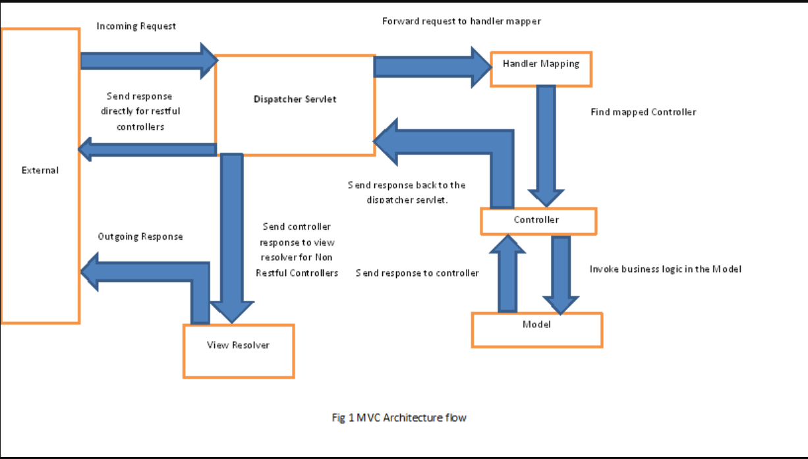

Software Principal is called SOLID

S -> Single Responsibility Principle

O -> Open for extension and closed for modification

L -> Liskov substitution principle

I -> Interface segregation principle

D -> Dependency Inversion Principle

Every class should own its one responsibility, Example if Employee class should contain the details of the employee like ID, name and salary.

We can create the separate class for Manager and labor and implement the interface called calculate salary.

OCP (Open for extension closed for modification): We have interface that does the calculation, We can implement this interface and call respective class to perform the operation.

IN order to follow OCP we need to follow SRP first. IN order to implement OCP we need to define the base class and create the fields needed in the below example it is Account class. Then create the interface called IAccount with should have a method calculate Interest with Account class as parameter. Finally implement the business functionality like calculate interest on SB current etc

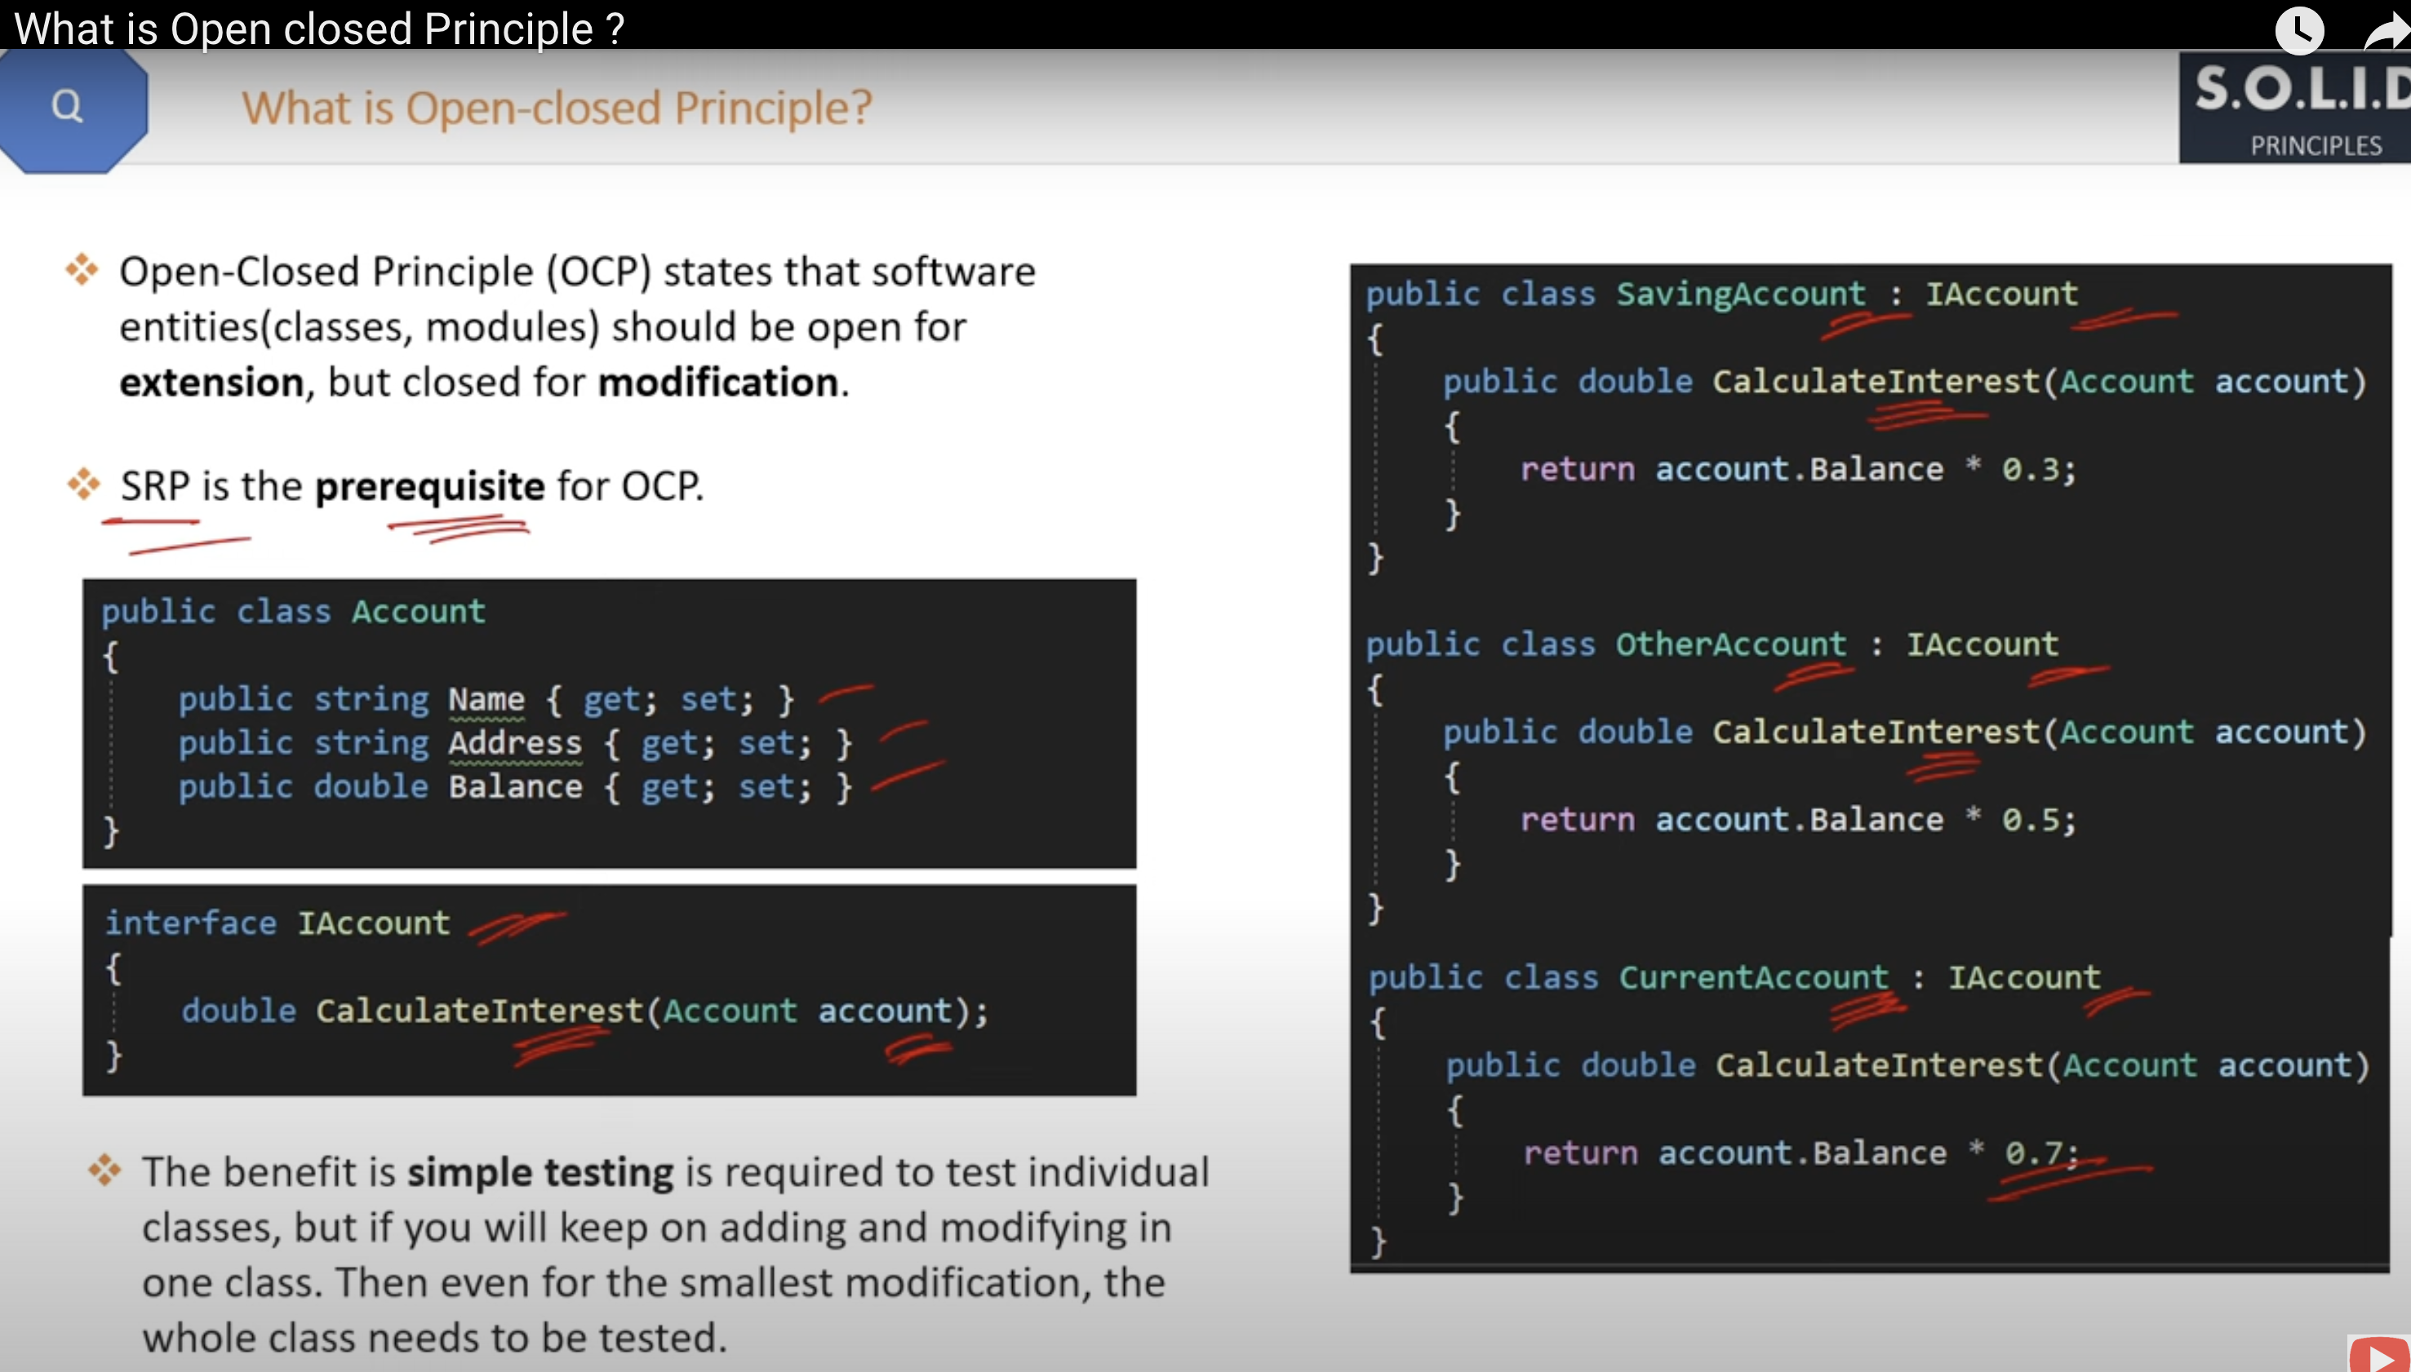

Example:

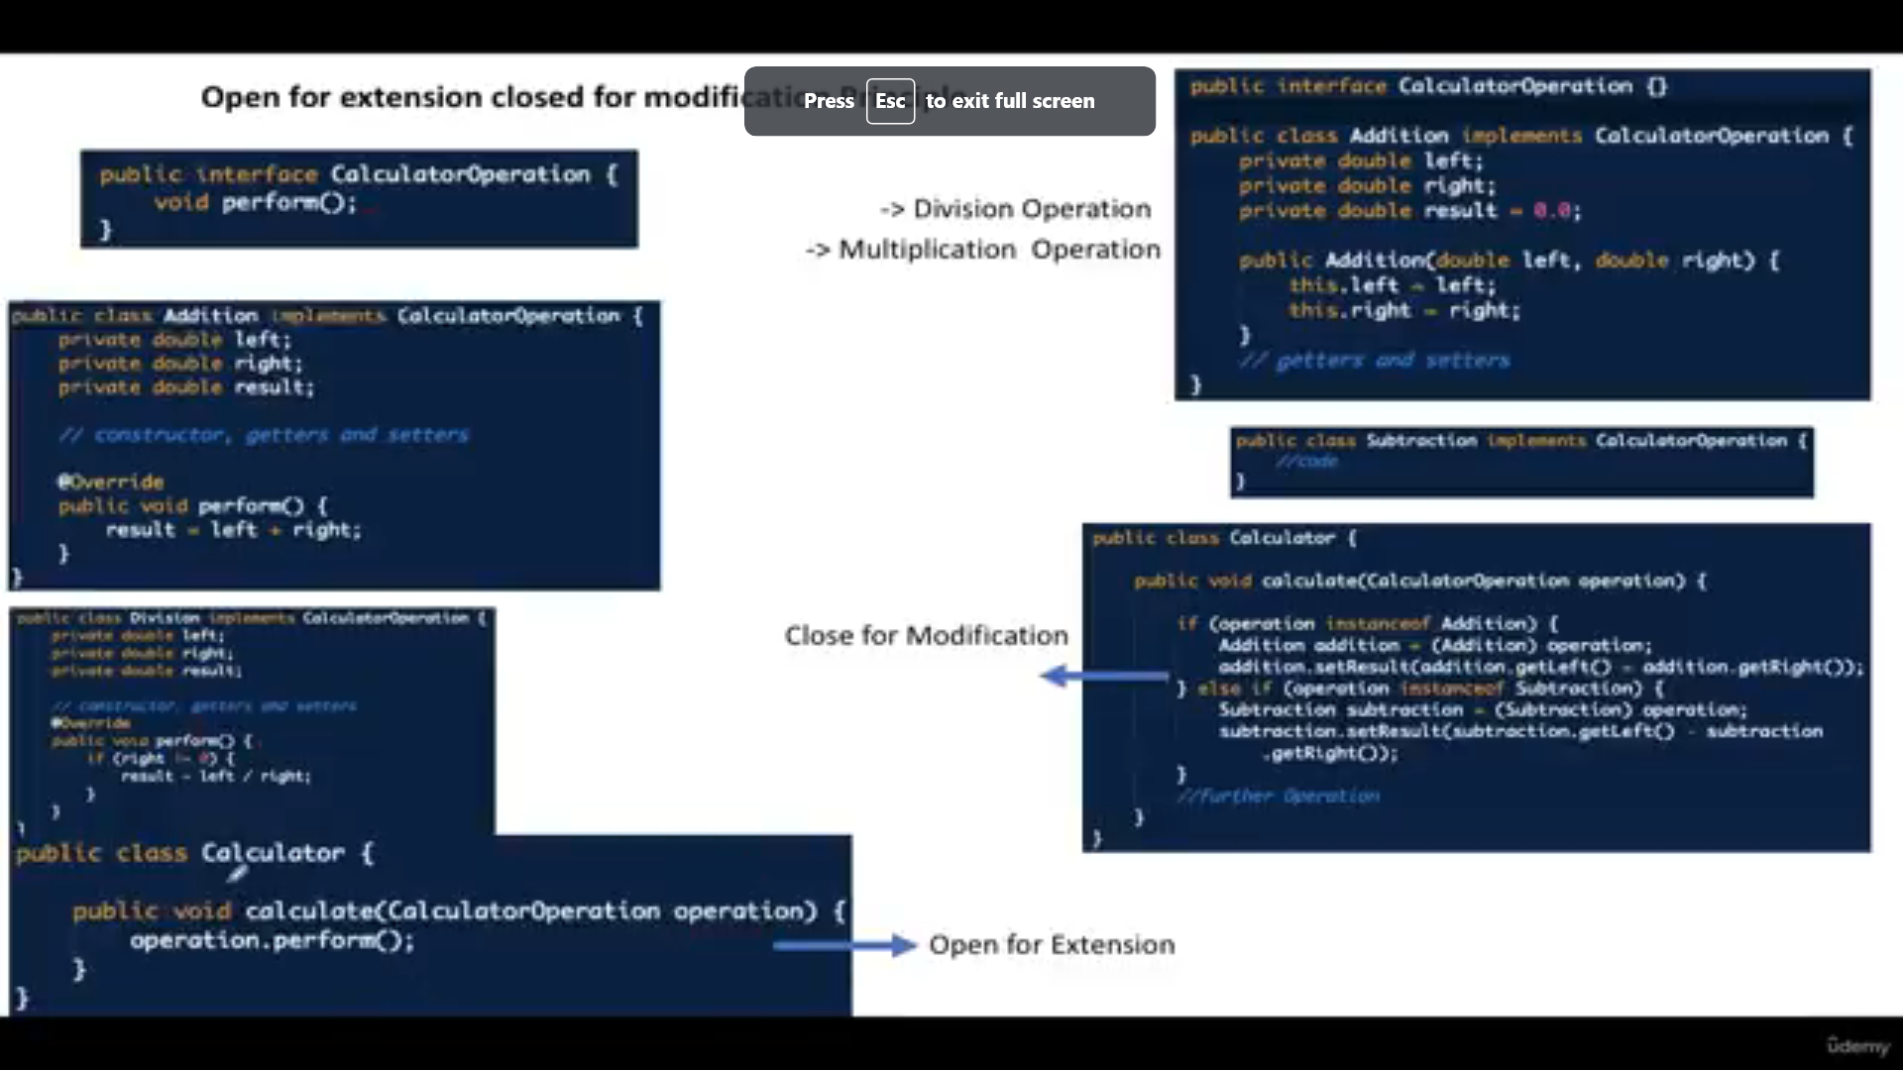

LSP (Lesko Substitution principle) : For example if we have class called common Bank account , If pay roll class is extending common account any one of the method is not needed to be implemented in payroll then we need throw an exception . Basically, sub types needs to be replaced by base type

But in LSP we need to create the Instance account manager class with constructor in common bank account, We don’t need to implement income method this is called LSP principle. .Refer below screen

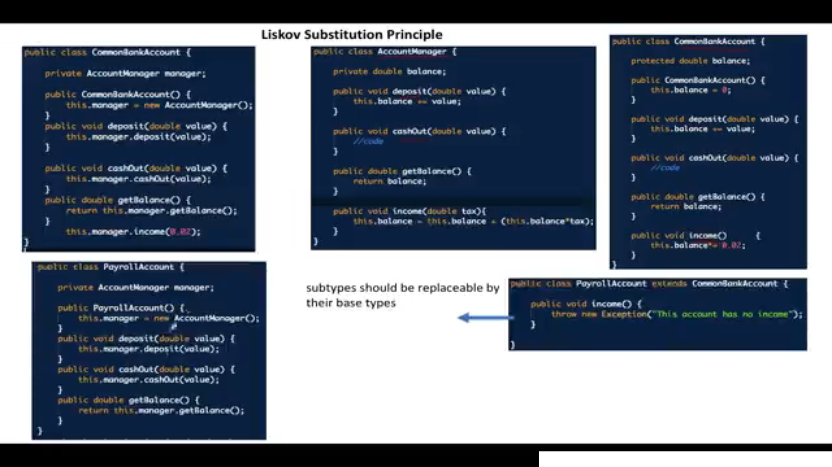

Interface Segregation principle : We should avoid developing the common interface with multiple methods, need to divide basis on client . In below example Machine B class does not needs a TASK D but we are forcing to implement it. This principal says we need to avoid this kind of design.

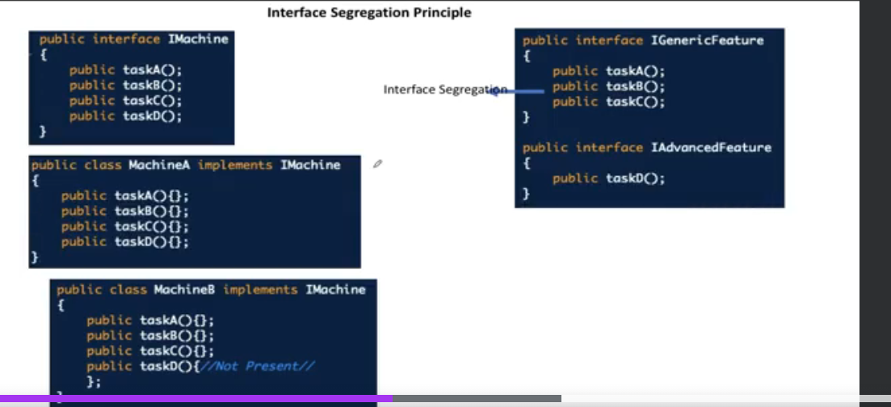h

Dependency Inversion Principle : High level model should not depend on low level module .For example if we create 2 classes like FE developer , BE developer then in main class we need to instantiate the a classes and implement the method but that is not correct as per Dependency inversion principle .

We need to create a interface and then create the concrete class and then create the object of class like List of Developers in below example

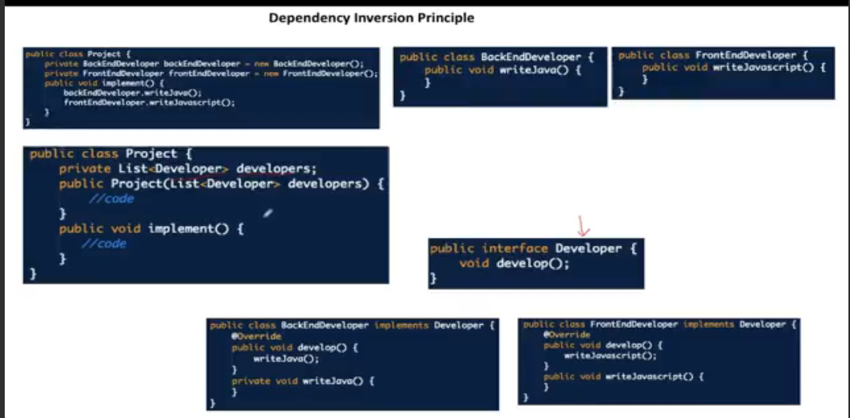

Singleton Pattren: To make the class as single ton we need to define the constructor as private

Also it should contain one static method it should create the instance of class , if it is null only . Also we need to synchronized key word to make sure muti thread is accessing will not allow to create the 2 instances

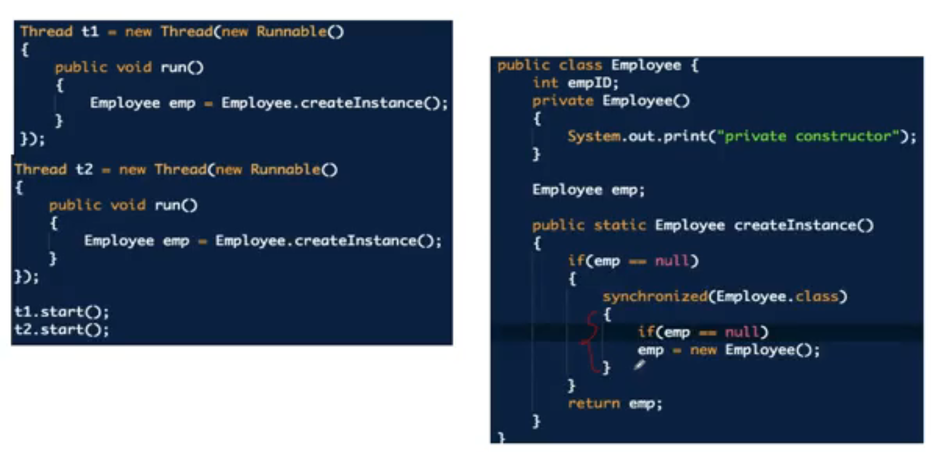

Factory Pattern : In this pattern basically we will not disclose the server business to client. In below example we have Abstarct class that contains 2 methods abstract FeatueAcesss() and abstract price(). This class will extend 2 classes Lifettime and Annuail , in this side this calls the abstract method will be provide 2 different implementation .

Below use will provide query with string Lifetime plan then we will invoke Lifetime class and provide the result.

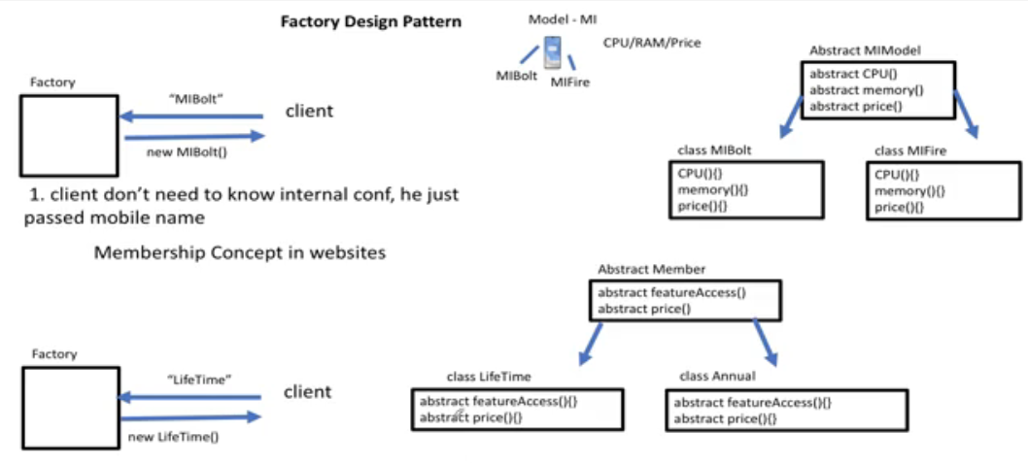

Below is code for Factory Pattern , In this below example if new specific model needs to be implemented in specific location it would be difficult in that case need to for abstract factory method

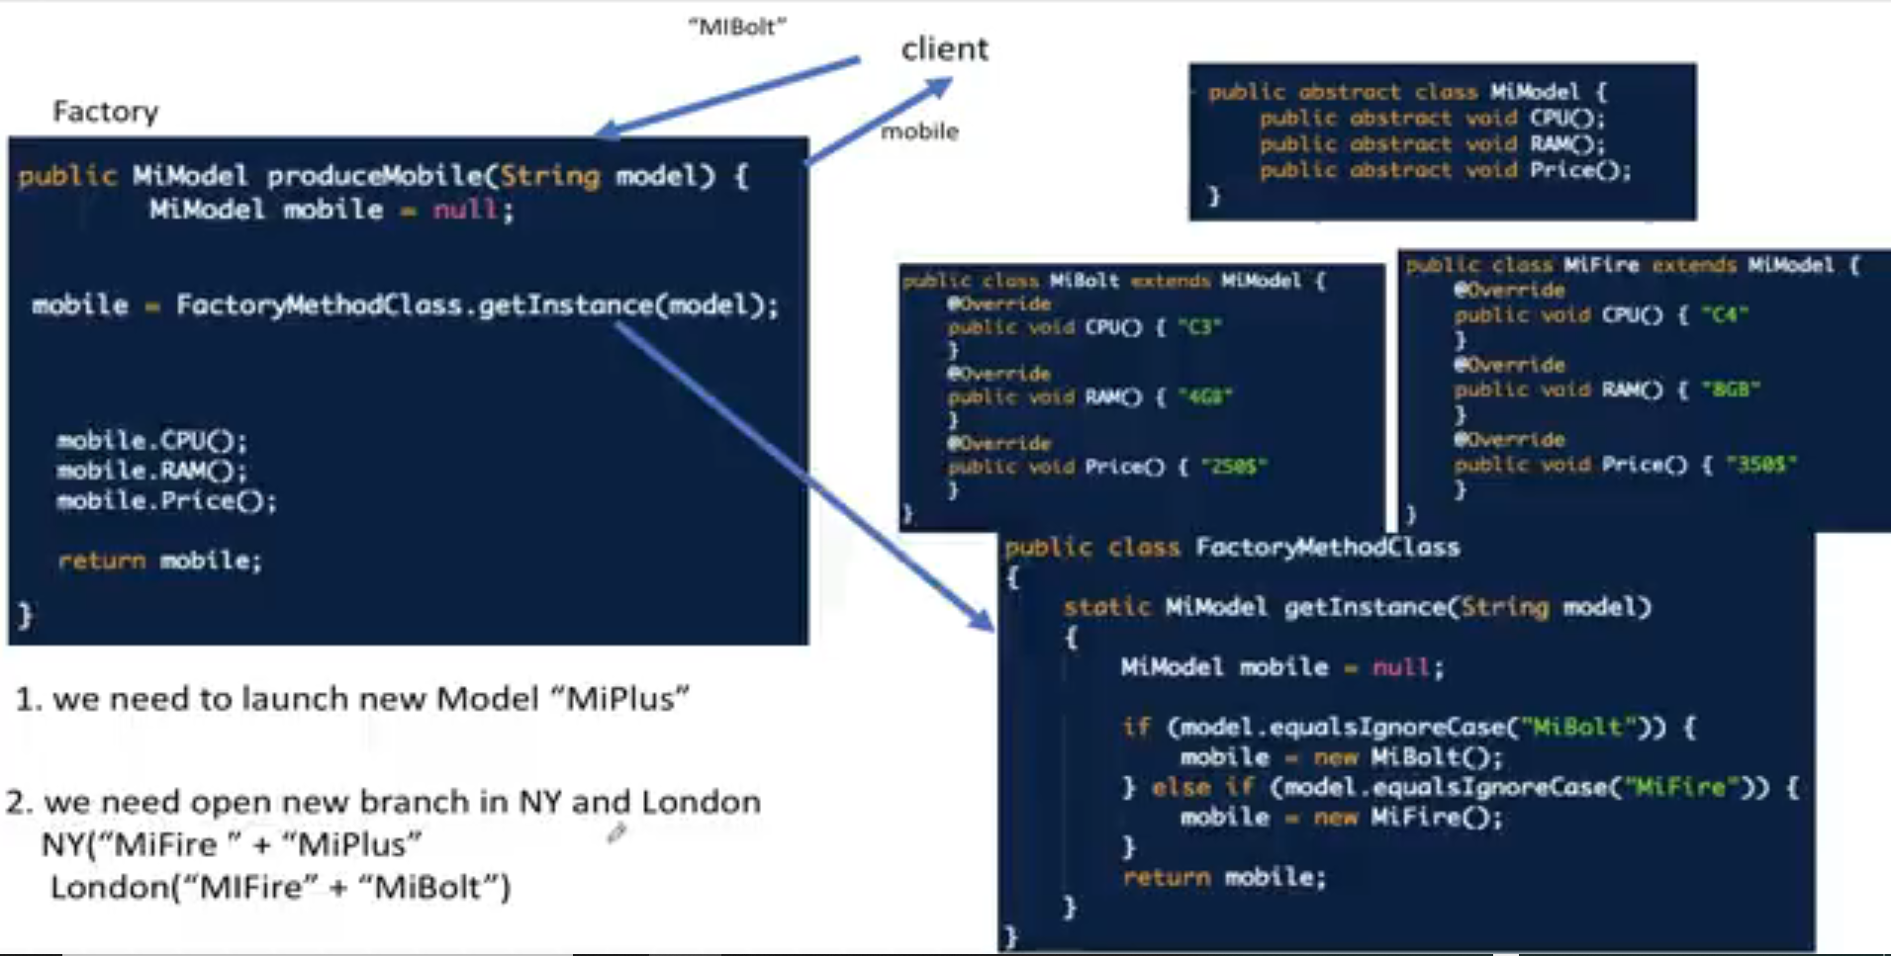

Abstract design pattern: In this design Factory class will be abstract class and respective location can extend this factory class and create the instance of the respective location and return to factory method class.

Note: Other abstract class is not shown in below diagram

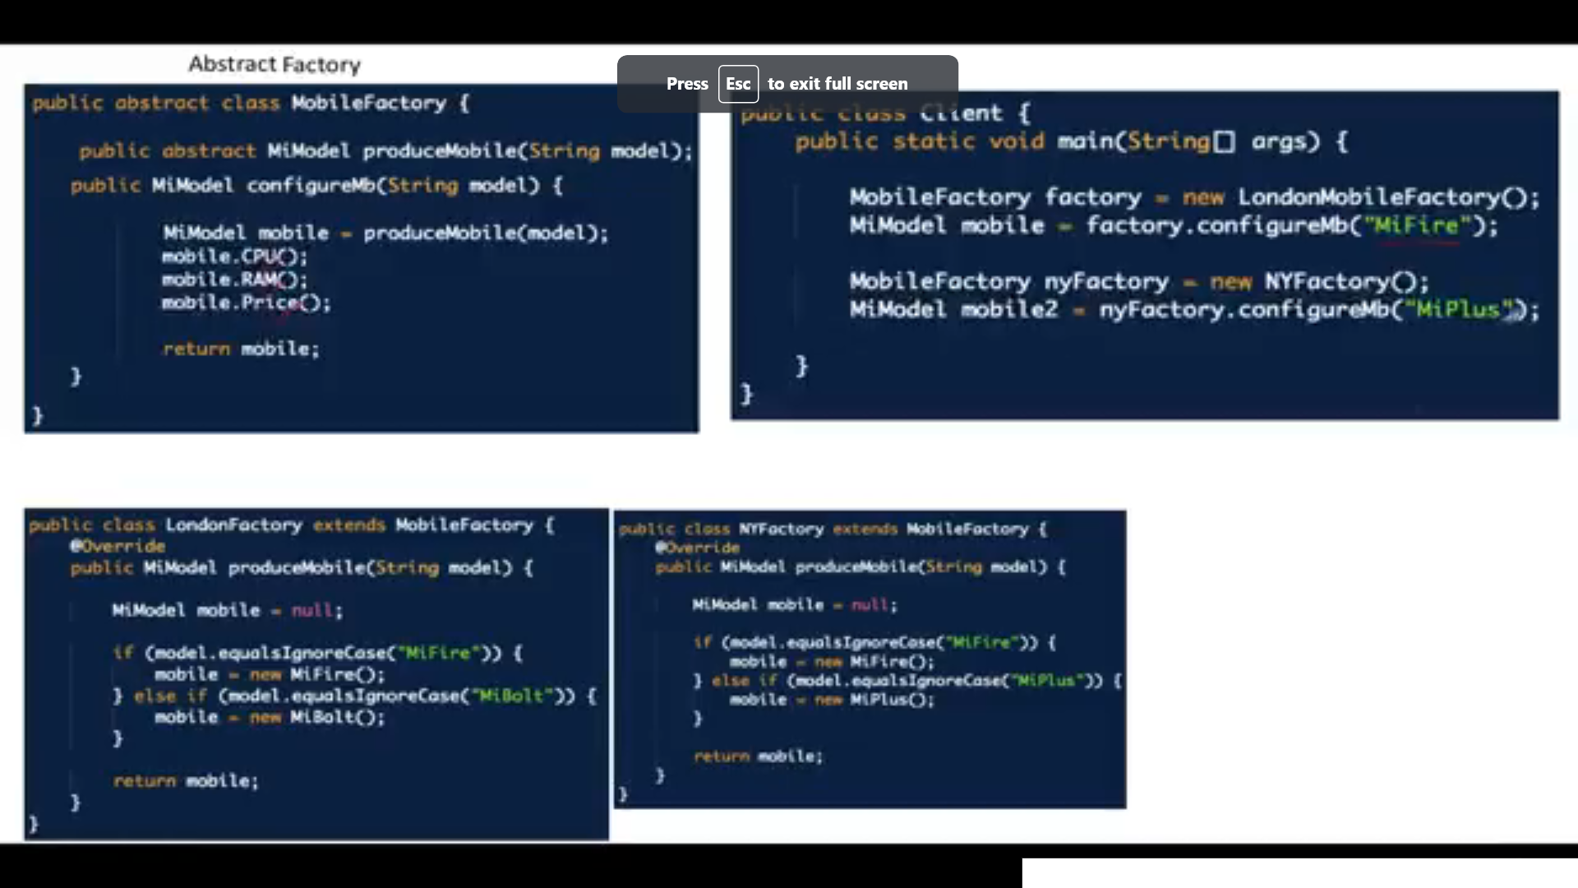

Statergy Design pattern it is part of Behavior design : Name suggest that this is been decided at run time , Example if user is making a payment for telephone bill , They can select either paypal or credit card . Basis on the selection current design should support passing the instance of respective class . Here we need to create the interface called Payment and it is been implemented by 2 different class one for credit card and other for paypal.

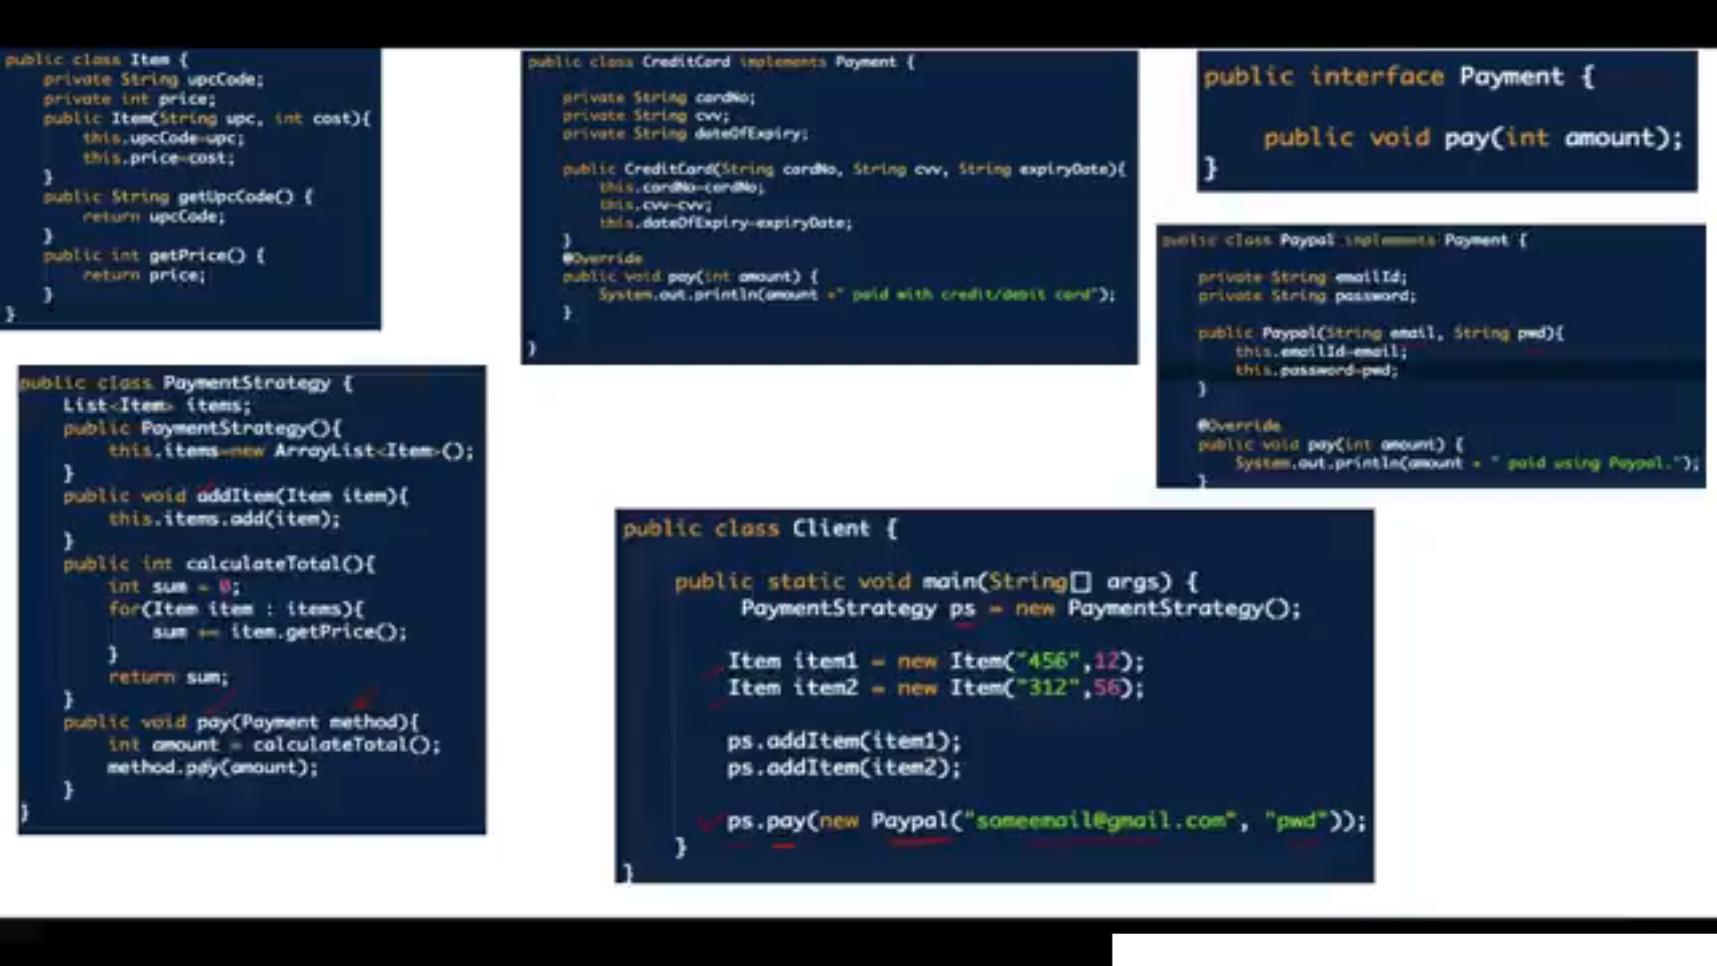

Observer Design Pattern This pattern is mainly used in Amazon, Linked in , you tube etc . This pattern also called Publish and subscription pattern.

It has a concept called Observer where it is called as user , Subject is called FacebookGroup . Observer will get the notification . Subject will register and store observer system.

Also subject needs to send the notification to Observer

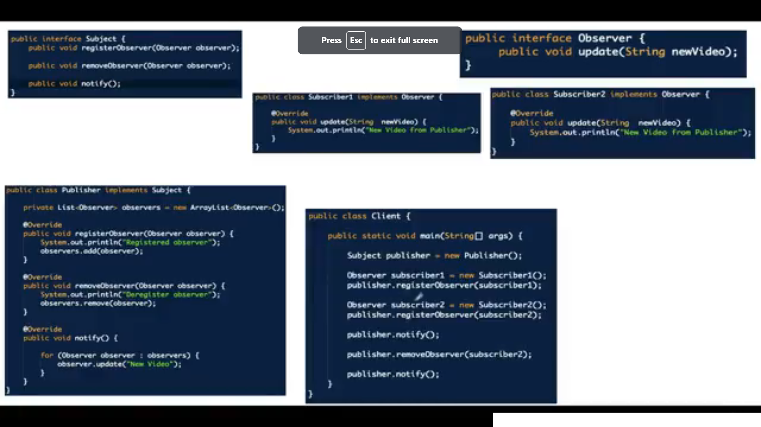g

Builder design patten is used to build complicated. Example if you have 2 model will be purchased by the user then we need to give them a plan for maintainece for a year or 6 months . in that case we need an another abstract class called service . Below diagram shows

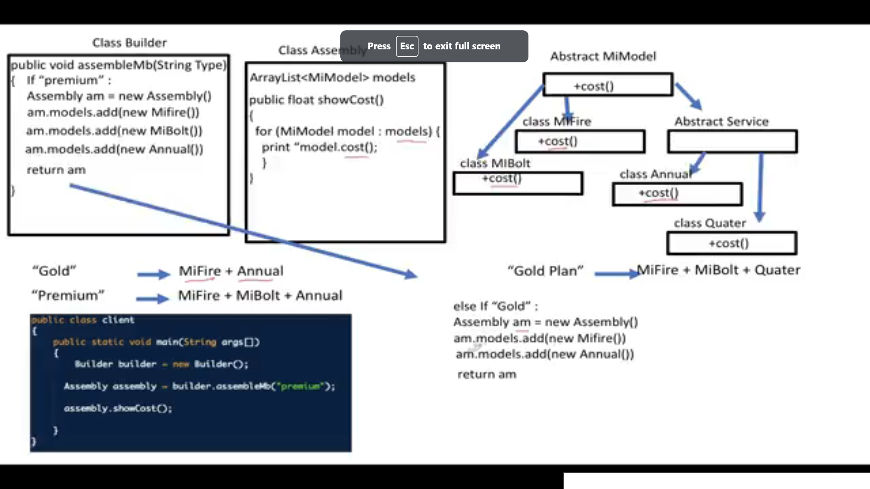

In vending machine or metro entry station, For this kind of system design we need to use State design pattern( Behavior design pattern) . Here each action will change the state for example if

Cascading Failure : Means if request fails from one micro service to another and subsequent dependency microservices also fails .It is called cascading microservice.

Circuit barker pattern is very useful is microservice to handle the failure . If called microservice is down then circuit breaker will not send feature request to dependent microservice .

It will keep track pass and fail count , If number of failure is more than the configured threshold then it will not sending the report . This kind of configuration also be done.

Below are the status of circuit broker OPEN CLOSED and HALF OPEN

Service Discovery will maintain the IP address of each microservice ad